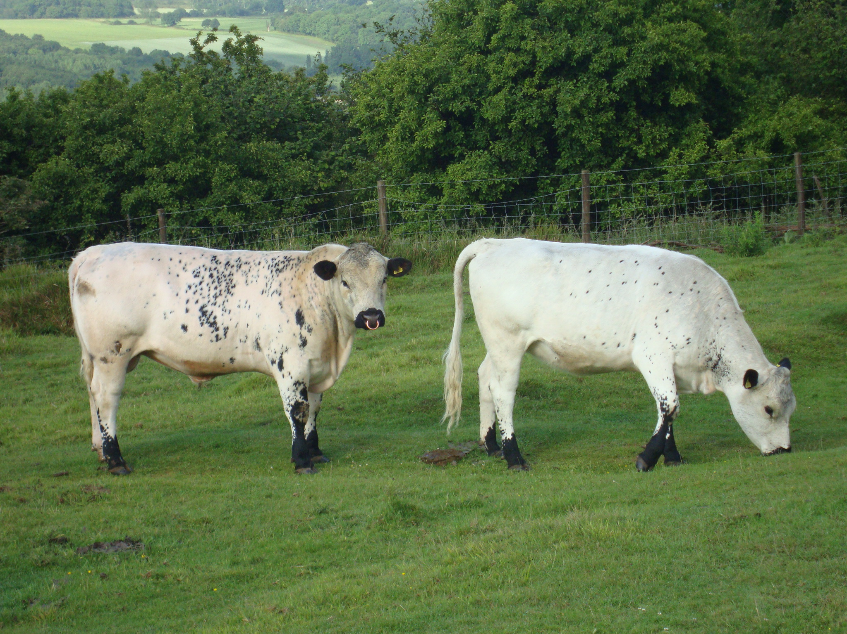

Wye Community Farm Beef box

The Wye Crown Herd of British White cattle was founded in Spring 2008, on commencement of our agreement with Natural England to graze part of the Wye National Nature Reserve. In grazing the chalk grassland on the reserve, the cattle play a vital role in maintaining habitats for a wide range of rare and endangered plants and animals.

British White cattle have a long and fascinating history, to learn more about the breed visit www.britishwhitecattle.co.uk . Allowed to mature slowly, our beef cattle are reared to 28-30 months before travelling to a local, family run abattoir where the beef is hung for three weeks to allow the full flavour to develop.

Each finished animal is split equally into 10 beef boxes, with a typical box containing: Sirloin Steak, Rump Steak, Frying Steak, Topside/Silverside, Ribs, Shoulder, Chuck Steak, Leg, Stewing Steak, Mince. Each box is priced at £150, weighing 16-18kg. We are also able to offer a half box for £80.

Wye Community Farm, 22 Church Street, Wye TN25 5BJ

www.wyecommunityfarm.org.uk
info@wyecommunityfarm.org.uk 01233 813298

Please reserve me a full/ half (delete as appropriate) WCF beef box

Name :……………………………………………………………………

Address:……………………………………………………………………….

Phone or e-mail………………………………………………………

