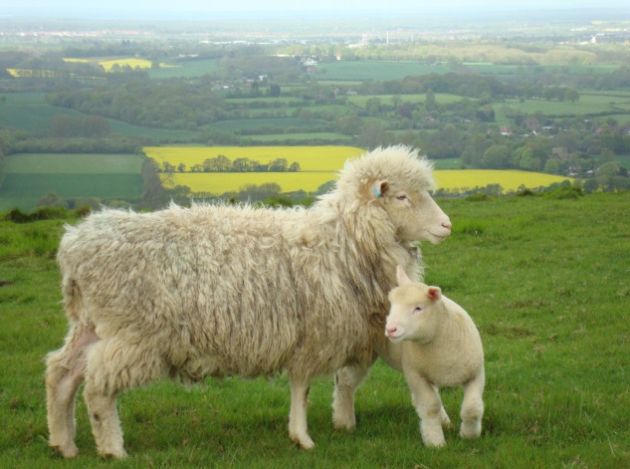

Wye Community Farm Lamb Box

We rear Poll Dorset and Portland sheep, two traditional breeds renowned for the flavour of their meat. See our flock on the Wye National Nature Reserve, where their grazing plays an important role in maintaining the chalk grassland that is home to a wide range of endangered species. When the time comes we use a local family run abattoir, ensuring the highest standards of animal welfare.

Each box contains half a lamb, butchered to your requirements, priced at £60. To place your order please fill in and return the form below.

Wye Community Farm, Rear of Brook Church, Brook, Ashford, Kent, TN25 5PF

www.wyecommunityfarm.org.uk
info@wyecommunityfarm.org.uk

Please reserve me a lamb box (circle cuts as appropriate):

Leg: whole/ half/ leg steaks boned and rolled
Shoulder: whole/ half boned and rolled
Best end: rack/ cutlets
Loin: whole/chops
Chump: chops
Breast: boned and rolled/ mince/ burgers
Neck: fillet/ stewing
Bones for stock: yes/ no

Name :……………………………………………………………………

Address:……………………………………………………………………….

Phone or e-mail………………………………………………………………..

