Wye Community Farm Pork Box

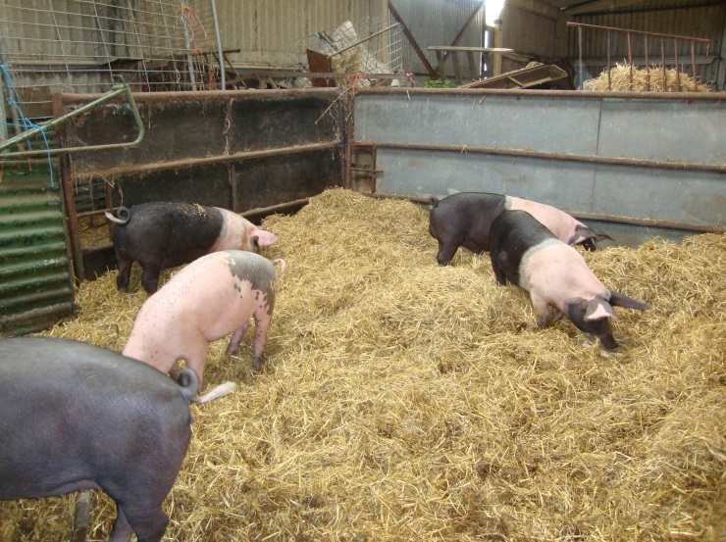

We purchase our pigs as weaners from a local Saddleback breeder, and fatten them on GM free pig feed and outgrade vegetables from Ripple Farm Organics. Our pigs have a happy life in our straw filled barn, being cared for by WCF volunteers and people carrying out their ‘community payback’ on the farm. When the time comes we use a local family run abattoir, ensuring the highest standards of animal welfare.

Four sizes of box are available to suit your requirements. Simply complete the form below and return to us by email or post, we will give you a couple of weeks’ notice on when your box will be available.

Wye Community Farm, Rear of Brook Church, Brook, Ashford, Kent, TN25 5PF

www.wyecommunityfarm.org.uk
info@wyecommunityfarm.org.uk

Please reserve me a pork box as indicated below

Pork boxes: containing a mix of joints, chops and sausages.
Large pork box (half a pig, min 18kg) £120
Medium pork box (min 9kg) £70
Small pork box (min 5kg) £40

Breakfast box
Bacon and sausages (min 4kg) £40

Contact details (Phone or e-mail)

..................................................................................................................................

